**Power outages increase cardiovascular and respiratory hospitalizations among US older adults**

**Heather McBrien1*, Daniel Mork2, Vivian Do1, Marianthi-Anna Kioumourtzoglou1, Joan A. Casey3,4**

**1 Columbia Mailman School of Public Health, Department of Environmental Health Sciences**

**2 Harvard T. H. Chan School of Public Health, Department of Biostatistics**

**3 University of Washington Department of Environmental and Occupational Health Sciences**

**4 University of Washington Department of Epidemiology**

**\* Corresponding author:** [**hm2913@cumc.columbia.edu**](mailto:hm2913@cumc.columbia.edu)

**Funding sources:**

**National Institute on Aging grant R01AG071024 (JAC)**

**National Institute of Environmental Health Sciences grant P30ES007033 (JAC)**

**R01ES034021, R01AG066793 (DM)**

**P20 AG093975, P30 ES009089 (MAK)**

**Canadian Institute for Health Research Doctoral Foreign Study Award (HM)**

**Abstract (max 250 words)**

**Background**: In the US, already prevalent power outages (1) are increasing in frequency and duration with climate change (2). Studies from New York State show that power outages may increase hospitalizations for cardiovascular disease (CVD) and respiratory disease in vulnerable populations such as older adults (3–6), but exposure data limitations have constrained nationwide studies of power outage and health (7).

**Question**: Are power outages associated with emergency CVD and respiratory disease-related hospitalizations among older adults in the contiguous US?

**Methods**: We developed a national dataset of power outage exposure (1,8) and identified county-days where ≥1% of customers were exposed to 8+ hour power outages in 2018. We used data on to 23 million Medicare Fee-For-Service beneficiaries aged 65+ to estimate daily county-level rates of emergency CVD and respiratory-related hospitalizations and used a case-crossover design with a conditional Poisson model (9) to estimate the lagged association with daily county-level power outage exposure. Models controlled for temperature, precipitation, and wind speed.

**Results**: Power outages increased both emergency CVD and respiratory hospitalizations. Effects of outage on CVD hospitalizations were largest the day after power outage exposure (rate ratio [RR]=1.020, 95% CI: 1.013, 1.026). Effects of outage on respiratory hospitalizations were largest the day of outage exposure (RR=1.026, 95% CI: 1.012, 1.039).

**Conclusion**: Power outages likely cause CVD and respiratory hospitalizations among US older adults. Improving electricity reliability could support community health and protect older adults from CVD and respiratory disease exacerbations.

**Introduction:**

As the climate warms, the incidence and duration of power outages across the US have increased (2). US electrical customers experienced an average of 8 hours without power in 2020—the longest duration on record (10). Aging electrical grid components, already at risk of failure, often break down during previously rare extreme weather events now common with climate change (7,11). 40-60% of major outages are now caused by severe weather events (1). Additionally, extreme heat and cold events will continue to increase electricity use, outstripping supply and causing outages (12,13).

Power outages threaten the health of vulnerable populations such as older adults (7,14) by disabling air conditioners and heaters, exposing those affected to extreme temperatures (15). This heat and cold exposure may cause or exacerbate respiratory and cardiovascular illness. Older adults are more likely to suffer health consequences from heat and cold exposure due to aging-related thermoregulation changes (16) and preexisting conditions (17,18). For example, 70-86% of older adults live with cardiovascular disease (CVD) (19), and over 3% of older adults use electricity-dependent medical equipment such as ventilators and oxygen tanks at home to treat conditions like COPD (7). For these individuals, loss of electricity can be life-threatening. Finally, prolonged loss of electricity to refrigerators, elevators, wheelchairs, and water disruptions can result in stress, isolation, dehydration, or injury. Older adults’ increased reliance on mobility devices and elevators and social isolation (20,21) may reduce their opportunities to seek out electricity, air conditioning, heat, or water to mitigate outage impacts, putting them at higher risk for outage-related cardiovascular and respiratory illness.

Prior epidemiologic studies in New York State found elevated cardiovascular and respiratory emergency department visits up to one week after power outage exposure for all adults, as well as increased cardiorespiratory hospitalizations and mortality (3–6).Associations may be stronger among older adults or when outdoor temperatures are extreme (4). Exposure data limitations have constrained nationwide studies of power outage and health (7). Only recently have population-level datasets of power outage exposure beyond New York State become available (1,22). Further, most studies outside of New York used large-scale events, such as single hurricanes that disrupted power as surrogates for power outage exposure and assumed everyone in a city or county was exposed to the index event (23,24). Such studies cannot disentangle the health effects of power outages from climate disasters. Despite often occurring with severe weather, most power outages do not co-occur with large disasters (25). We require a comprehensive understanding of the health impacts of increasingly frequent moderate and large-scale power outages to inform prevention efforts.

We previously assembled the first nationwide dataset of hourly county-level power outage exposure from 2018-2020 based on data from PowerOutage.us (1,26). Here, we leverage these data together with Fee-For-Service Medicare hospitalization data to estimate the relationship between daily power outage exposure and cardiovascular and respiratory hospitalization rates in the contiguous US. We evaluate impacts of increasingly large power outages and conduct secondary analyses examining effect measure modification by age, sex, poverty, and electricity-dependent durable medical equipment (DME) use.

**Materials and Methods:**

**Study population:**

Our study population included all Fee-For-Service Medicare beneficiaries aged 65+, enrolled for at least one month between January 1st, 2018 and December 31st, 2018. From the Medicare beneficiary record file, we obtained age, sex, county, and state of residence for all beneficiaries. We initially included 33,242,414 beneficiaries.

We used the Medicare Provider Analysis and Review (MEDPAR) file to access inpatient claims data on all hospitalizations in our study population in 2018 from the Centers for Medicare and Medicaid Services (CMS). We accessed the date of hospitalization, type of hospitalization (emergency, urgent, or planned), and cause of hospitalization via *International Classification of Diseases*, Tenth Revision (*ICD*-10) diagnostic codes.

**Outcome assessment:**

Using beneficiaries’ county of residence, we tabulated the number of Medicare beneficiaries for all US counties and states. We also tabulated daily, county-level counts of urgent and emergency hospitalizations for cardiovascular or respiratory causes based on the hospitalized beneficiary’s county of residence. We used *ICD* codes to identify CVD (I00-I99) and respiratory (J00-J99) hospitalizations based on the first five codes recorded as hospitalization cause. We included only urgent and emergency hospitalizations since we hypothesized that power outages would increase emergency and urgent hospitalization rates, but not scheduled hospitalizations, due to short-term heat, cold, and electricity-dependent medical device disruption.

We excluded counties with ≤500 beneficiaries due to their unstable hospitalization rates (n=178 counties). Our final outcome dataset included daily county-level rates of CVD and respiratory hospitalizations among older adults for n= 2,964 or 94% of US counties.

**Exposure assessment:**

We used PowerOutage.us (POUS) (26) nationwide county-level data to assess power outage exposure for 2018. These data included the number of customers without power every hour by county. ‘Customers’ refers to residential consumers, such as households or families, and non-residential consumers, such as businesses. Because estimates of customers served by county from POUS were unreliable, we used EIA estimates of customers served by state (27) and 2013-2018 American Community Survey estimates of the number of households and establishments by county to determine the proportion of state customers in each county. This allowed us to allocate state-level customers to each county, estimating the number of customers served in each county.

Substantial exposure data were missing from the POUS dataset. Previously, we conducted a simulation study to test the impacts of this missing data on an epidemiologic study like the one we conducted herein (8). We found that when 16% of county-hours were missing from a power outage exposure dataset, results of an epidemiologic study like this one would be biased towards the null by 13%. Based on these results, to balance generalizability and bias, we excluded counties with 50% of county-hours missing in the POUS data (n=804 counties). After excluding counties with low beneficiary counts and missing data, our analytic dataset included 2,161 counties (69%), covering 71% of 2018 Fee-For-Service Medicare beneficiaries (N = 23,622,770). These study counties were missing 7% of total power outage county-hours. When counties were missing 4 or fewer hours of consecutive exposure data, we used last observation carried forward to interpolate those hours.

We were interested in understanding the health impacts of common outages rather than only large-scale ones associated with disasters. Therefore, we considered a county-day exposed to power outage if ≥1% of county customers were without power for 8 or more consecutive hours on that day. In cases where an 8+ hour power outage spanned two days but neither day had 8 total hours of exposure alone, we considered the second day exposed. This exposure assignment resulted in an average of ≥109 Fee-For-Service Medicare study participants being exposed on a power outage day. Prior studies evaluated the health impacts of similar size outages, and observed associations with cardiovascular and respiratory health outcomes (3–5,28). We also assessed the impacts of larger-scale outages affecting ≥3% and ≥5% of county customers.

We analyzed 8+ hour power outages because we hypothesized that indoor temperatures would change substantially over this time, exposing older adults to heat and cold. Further, batteries for most electricity-dependent medical equipment last 8 hours. During a power outage, electricity-dependent medical device users could experience adverse health effects without their equipment immediately after losing power to the equipment.

Because there is no literature on the health-relevant duration of power outage, beyond epidemiologic studies showing health impacts of outages of certain lengths (3–5,23,28,29), we conducted a sensitivity analysis on the power outage duration. We evaluated the effects of 4+ hour outages and 12+ hour outages on both hospitalization rates. We also conducted a sensitivity analysis where we used a continuous metric of “daily number of hours without power” (hours where ≥1% of the population was without power) to assess for a threshold in power outage duration.

As in all available population-level power outage datasets, counts of customers without power reported in the POUS dataset do not necessarily track the same customers over time (22,26). If 10 customers were reported out in two subsequent hours in one county, the data do not contain information about whether the same 10 customers lacked power or if, for example, 10 customers were without power in the first hour and a different 10 customers were without power in the second hour, meaning 20 customers were without power for 1 hour each. Therefore, when measuring exposure to 8+ hour power outages affecting ≥1% of the population, it is not guaranteed that the same ≥1% of county customers experienced 8 consecutive hours of power outage. Though we aim to capture individuals’ exposure to power outage with this definition, there is substantial error. These outages represent some level of large power outage exposure among individuals in a county.

**Statistical analysis**

We used a case-crossover design with a conditional Poisson model (9) to analyze the association between daily county-level power outage exposure and CVD and respiratory hospitalization rates separately in two different models. We used separate models because heat, cold, loss of power to medical devices, and dehydration affect CVD and respiratory disease differently (30–32). We selected control days for every county-day with a non-zero hospitalization count, matching on county, day of week, and month. This matching automatically controlled for time-invariant or slowly changing confounders like county-level socioeconomic characteristics, which could affect both hospitalization rates and power outage rates, as well as seasonal and day-of-week trends.

However, this design does not automatically control for time-varying confounders. We controlled for wind speed, temperature, and precipitation, which can all influence both power outage and hospitalization rates. We used daily county-level maximum temperature, average wind speed, and total precipitation measures from gridMET, a dataset of daily high-spatial resolution (~4 km, 1/24th degree) surface meteorological data (33). We included maximum temperature flexibly in our models as a natural spline with 3 degrees of freedom. To determine how flexibly to control for wind speed and precipitation, we removed power outage exposure from models and modelled only the relationships between precipitation, wind speed, and CVD and respiratory hospitalization rates separately. We ran several test models with splines on precipitation and wind speed with varying degrees of flexibility (linear, and 2-4 degrees of freedom), and tested model fit using qAICs. We controlled for these confounders in main models with the degree of flexibility that resulted in the best test model fit. In models with the outcome of respiratory hospitalizations, we controlled for precipitation linearly, and in models for CVD outcomes, with 2 degrees of freedom. Wind speed was modeled with 3 degrees of freedom across outcomes.

We hypothesized that there would be lagged effects of power outage on CVD and respiratory hospitalizations. Power outage exposure was moderately autocorrelated ( = 0.2). We included lags up to 6 days after power outage exposure and constrained these lags. We tested 3-5 degrees of freedom on the lag dimension since >5 degrees of freedom seemed biologically implausible. We compared model fit using qAICs, finding that for CVD outcomes, 5 degrees of freedom across the lag dimension produced the best model fit, and 3 degrees of freedom for respiratory outcomes.

We conducted secondary analyses for power outages affecting ≥3% or ≥5% of county customers, rather than ≥1%, to evaluate the impacts of larger, rare outages, during which we hypothesized stronger health effects.

In another secondary analysis, we used distributed non-linear lag terms in the conditional Poisson model to determine the relationship between continuous daily county-level number of hours without power and hospitalization rates and to test for possible threshold effects.

We used qAICs to find the best-fitting model among eight models. We varied two parameters: we either modeled the exposure-response function as linear or with a natural spline with 3 degrees of freedom, and we also tested 3-6 degrees of freedom on the lag dimension.

**Testing for effect modification**

We tested for effect modification of the association of power outage exposure on CVD and respiratory outcomes by age and sex. We stratified analyses by age, for those 75+ and <75, and by sex (male and female; there is no gender reporting or option to record sex as intersex in CMS records). We also tested for effect modification by county-level poverty status. We calculated the proportion of county households making less than the federal poverty income using 2013-2018 American Community Survey data and stratified analyses by quartiles of this measure. Finally, we tested for effect modification by the percentage of total Medicare beneficiaries using DME by county estimated from emPOWER data. emPOWER provides the number of Medicare beneficiaries (all, not only Fee-For-Service beneficiaries aged 65+, as in our study population) using DME and the total number of beneficiaries by county. We calculated the percentage of DME users by county and stratified analyses by quartiles of percentage of DME users.

**Results**

Our analysis included 2,161 counties, which experienced an average of 7 (SD=28) 8+ hour power outages affecting ≥1% of customers in 2018 and covered 71.1% of Medicare Fee-For-Service beneficiaries. The number of beneficiaries per included county ranged from 501 to 252,004. Just over two percent of county-days were exposed to a power outage (n=15,990 county-days). The mean daily county-level emergency? CVD hospitalization rate was 3.23 per XX, and the respiratory rate was 2.25 per YY. The most common causes of emergency CVD hospitalization were primary hypertension (XX%, I10), hypertensive heart and chronic kidney disease with heart failure (XX%, I30), and hypertensive heart disease with heart failure (XX%, I110). The most common causes of emergency respiratory hospitalization were acute respiratory failure with hypoxia (XX%, J96.01), acute COPD exacerbation (XX%, J44.1), and unspecified COPD (XX%, J44.9).

**CVD hospitalizations**

Main analysis

In our main analysis testing the effect of 8+ hour power outage exposure on emergency CVD hospitalization rates, we found increases in CVD-related hospitalizations 1-3 days after and 6 days after power outage exposure (**Figure 2**). Exposure was not associated with increased hospitalizations on other lag days. One day following power outage exposure, the CVD hospitalization rate was, on average, 1.020 (CI: 1.013, 1.026) times higher than on unexposed days (**Supplemental Table 1**).

We also analyzed larger outages affecting ≥3% or ≥5% of county customers and observed stronger associations for larger outages. For outages affecting ≥3% of county customers, CVD rates were more elevated than for outages affecting ≥1% of county customers the day after exposure, two days after exposure, and a week after exposure (**Figure 2**). Outages affecting ≥5% of customers were associated with even higher hospitalization rates. For outages affecting ≥3% of county customers, the day after outage CVD rates were 1.027 (CI: 1.018, 1.036) times higher than on unexposed days. For outages affecting ≥5% of the population, rates were 1.031 (CI: 1.021, 1.042) times higher than on unexposed days.

Sensitivity analysis

We conducted sensitivity analyses evaluating the impact of 4+ and 12+ hour outages on CVD hospitalization rates. We also modelled the relationship between daily county-level number of hours without power and CVD hospitalizations.

For 4+ hour and 12+ hour outages, we observed similar results to 8+ hour outages. Hospitalizations were elevated on lag days 1-3 and 6. The effects of 12+ hour outages on CVD hospitalizations were stronger than for 8+ hour outages, and 8+ hour outage effects were stronger than 4+ hour outage effects (**Supplemental Figure 1**).

We used a distributed lag non-linear conditional Poisson model to examine the relationship between continuous daily county-level number of hours without power and CVD hospitalization rates. The best-fitting model was linear for the association between number of hours without power and CVD hospitalizations with 4 degrees of freedom on the lag dimension. For every additional hour without power, the next-day CVD hospitalization rate increased by 0.1% and, therefore, by 2.4% for 24 hours without power (**Supplemental Figure 2**).

**Respiratory hospitalizations**

Main analysis

In our main analysis testing the effect of 8+ hour power outage exposure on emergency respiratory hospitalization rates, we found same-day increases in respiratory-related hospitalizations, as well as increases on lag days 1 and 2. In contrast to CVD hospitalizations, the strongest effect of outage on hospitalization was the day of power outage rather than the day after. On day of power outage exposure, the respiratory hospitalization rate was 1.026 (95 % CI: 1.012, 1.039) times higher compared to unexposed days.

Effects of 8+ hour outages affecting ≥3% or ≥5% of county customers on respiratory hospitalizations were stronger than those affecting ≥1%. For outages affecting ≥3% and ≥5% of county customers respectively, on exposed days, respiratory hospitalization rates were 1.052 (95% CI: 1.034, 1.071) times higher and 1.067 (95% CI: 1.045, 1.089) times higher than rates on unexposed days.

Sensitivity analysis

For sensitivity analyses evaluating the impact of 4+ and 12+ hour outages in addition to 8+ hour outages, we found the strongest effects on respiratory hospitalizations following 12+ hour outage exposure. Effect size decreased across outage durations as duration decreased. Respiratory hospitalization rates were 1.032 times higher (95% CI: 1.017, 1.047) the day of 12+ hour power outage exposure, 1.026 times higher (95% CI: 1.012, 1.039) the day of 8+ hour outage exposure, and 1.013 times higher (95% CI: 1.002, 1.023) the day of 4+ hour outage exposure compared to unexposed days.

Finally, we used a distributed lag non-linear conditional Poisson model to determine the relationship between continuous number of hours without power and respiratory hospitalization rates. The best-fitting model determined by qAIC modelled a linear relationship between number of hours without power and respiratory hospitalizations, with 4 degrees of freedom on the lag dimension. For every additional hour without power, the next-day respiratory hospitalization rate increased by 0.11% or 2.64% following 24 hours of power outage (**Supplemental Figure 2**).

**Effect modification**

We tested for effect modification of the relationship between power outage and CVD and respiratory hospitalizations by age, sex, county-level poverty, and percentage of county Medicare beneficiaries using DME. Overall, we did not observe effect modification by age, sex, or county-level poverty. However, the effect of power outage on respiratory hospitalizations appeared stronger in counties with smaller percentages of DME users (quartile 1 of DME use) compared to counties with larger percentages of DME users (quartile 4 of DME use). Respiratory hospitalizations remained elevated in counties with quartile 1 DME use for two days after power outage, while in counties with fourth quartile DME use, hospitalizations were elevated only on the day of power outage (**Figure 3**).

**Discussion**

In this 2018 study of 23 million Medicare beneficiaries aged 65+, we found that power outages increased acute emergency CVD and respiratory hospitalizations. Outage effects for CVD peaked on the day after power outage exposure and on the same-day for respiratory hospitalizations. As expected, larger outages affecting ≥3% or ≥5% versus ≥1% of county customers had larger effects on hospitalization rates. Furthermore, power outages were prevalent. US counties experienced an average of seven 8+ hour outages affecting ≥1% of customers in 2018, and shorter outages were even more common. With outage frequency and duration increasing due to climate change, these outages pose a growing threat to the cardiovascular and respiratory health of older adults.

Several New York State-based studies have shown that power outages increase CVD and respiratory acute care visits, with potentially stronger effects for older versus younger adults (3–5,28). In New York State, Deng et al. found the largest increases in CVD emergency department visits the day after exposure, while respiratory visits increased most on the day of exposure; the same pattern as our results. Using New York State-specific power outage data with high spatial resolution, Do et al. measured the effects of power outage on CVD hospitalizations in Medicare beneficiaries 65+ in New York State from 2017-2018, which overlaps our study period and population. They found elevated emergency CVD hospitalizations one day after power outage exposure, though confidence intervals crossed the null (28). We estimated similar effects with more precision because of our larger study population.

We hypothesized that power outages lead to CVD and respiratory hospitalizations in older adults because they cause heat exposure, cold exposure, stress, and loss of electricity to life-sustaining medical devices and mobility aids. Power outages may also cause changes in indoor air quality when dehumidifiers, air purifiers, and ventilation systems lose power. Further, many power outages are caused by climate-related severe weather like heat waves, winter storms, hurricanes, wildfires, and floods (7,25,34), which likely amplifies health risks (4,35,36). While we did not directly assess co-exposure to extreme weather, we controlled for temperature, wind, and precipitation as confounders. Enabled by new national datasets of power outage exposure (22,26), future studies should examine the health effects of outages and severe weather together. If power outages mediate the relationship between severe weather and hospitalizations, improving electricity reliability could mitigate the effects of climate hazards.

In this study, larger outages affecting ≥3% or ≥5% versus ≥1% of county customers were associated with higher hospitalization rates. The reason may be two-fold. First, the effects of larger outages on hospitalization rates may appear stronger because the exposure is measured more accurately. We expect less exposure misclassification when county-days are considered exposed to power outage when ≥5% of county customers are without power, compared to ≥1% of customers. Exposure misclassification may bias results, likely toward the null, though the magnitude and direction of bias are unknown. Second, larger outages may also cause more hospitalizations because they are community-wide events (7,36). During a small power outage, older adults may be able to rely on neighbors or other nearby community resources for social support, electricity, heat, or air conditioning. During a larger outage, fewer places have power, and fewer people can help. More individuals may, therefore, be exposed to the midstream effects of power outage, such as heat and cold, during these larger outages, potentially increasing hospitalizations.

We tested for effect modification of the power outage-hospitalization association by sex, age and area-level poverty and DME use. Contrary to our hypotheses, we did not observe effect modification by sex, age, or county poverty quartile. Because we measured poverty at the county level, and wealth varies widely within counties, average poverty levels may not accurately reflect adaptive capacity of individuals within counties. Higher resolution data may be necessary to test for effect modification by community socioeconomic status. We did observe effect modification by DME use quartile. Counties with higher prevalence of DME use (4th quartile DME use) in the full Medicare population had lower hospitalization rates after power outage exposure than counties with lower DME use (1st quartile). We hypothesized the opposite: that DME versus non-DME users would be more vulnerable to health effects from power outage. Several factors may explain the unexpected findings. First, power outages could cause more mortality among DME versus non-DME users, so mortality would act differentially as a competing risk for hospitalization in the DME user group. Second, DME users may be more prepared for outages compared to non-DME users, with greater access to generators or back up batteries. Third, all DME users may not be equally vulnerable to health effects from power outage. We measured county DME use based on how many Medicare beneficiaries used any type of DME, including wheelchairs, beds, oxygen equipment, ventilators, augmentative and alternative communication devices, and more. People using life-sustaining DME such as oxygen and ventilators may be more vulnerable to health effects from power outage than other DME users, but we were unable to separate this group out for analysis. At the same time, DME use may indicate better access to health care, and higher adaptive capacity. Finally, the counts used to generate our DME use quartiles are based on the full Medicare population, while only Fee-For-Service Medicare beneficiaries comprise our study population. Using the same population to generate DME use quartiles would have been more informative, but we lacked the data to do so.

Study limitations

In this study we measured county-level power outage, since no national finer-resolution power outage exposure data are available. We considered a county-day exposed to power outage if ≥1% of county customers were without power for 8+ consecutive hours, a definition that may have significant exposure misclassification (up to 99% of customers may be unexposed on a power outage day). This misclassification could bias study results, the magnitude of bias remains unknown. This question could be addressed in a simulation study or with individual-level power outage data. Future studies could collaborate with utilities to obtain finer-resolution power outage data or use satellite imagery to identify exact outage boundaries during long duration outages.

We also measured poverty and DME use, potential effect modifiers, at the county level. Because counties are large and diverse, this likely impacted our ability to detect effect modification by these factors.

Finally, the POUS dataset we used to measure exposure is missing substantial data. We excluded counties missing more than 50% of customer-hours in 2018 to balance generalizability and bias from missing data based on our prior simulation studies (8). Many counties missing >50% of exposure data were rural with low customer counts. Other studies of power outage and health have found differential effects of power outage on health by urban or rural status (28,29). Because we excluded many rural counties, our results may not generalize to these areas.

Despite these limitations, this study is the first US national study of power outage and health outcomes. We had adequate power to detect effects of power outage on health, making our results more precise and generalizable than studies limited to New York State. Our choice of a case-crossover design automatically controlled for many potential county-level confounders, and we studied a large population of 23 million older adult fee-for-service Medicare beneficiaries.

**Conclusion**

In this first national study of power outage exposure, we found that power outages were associated with increased CVD and respiratory hospitalization rates among 23 million older adult Medicare beneficiaries. We observed broad exposure and power outage frequency and duration will increase further with climate change. Heat, winter storms, or other climate-related weather events co-occurring power outages likely amplify cardiorespiratory health impacts and must be evaluated in future research. Improving electricity reliability represents a key opportunity to support community health and protect older adults from CVD and respiratory disease exacerbations.

**Tables and Figures**

**Table 1:** Distribution of power outage by 2018 Medicare Fee-For-Service study population sociodemographics and weather variables

|  |  |  |  |  |  |
| --- | --- | --- | --- | --- | --- |
| Distribution of power outage by potential confounders | | | | | |
|  | | | | Proportion of county-days with 8+ hour power outage affecting ≥1% of county customers by potential confounder quartiles | |
| Wind speed | | | | | |
|  | | Quartile 1 | | 0.009 | |
|  | | Quartile 2 | | 0.009 | |
|  | | Quartile 3 | | 0.010 | |
|  | | Quartile 4 | | 0.022 | |
| Precipitation | | | | | |
|  | | Quartile 1 | | 0.013 | |
|  | | Quartile 2 | | 0.014 | |
|  | | Quartile 3 | | 0.012 | |
|  | | Quartile 4 | | 0.011 | |
| Daily maximum temperature | | | | | |
|  | | Quartile 1 | | 0.022 | |
|  | | Quartile 2 | | 0.012 | |
|  | | Quartile 3 | | 0.009 | |
|  | | Quartile 4 | | 0.008 | |
|  | |  | |  | |
| Distribution of power outage by demographic variables | | | | | |
|  | | | Number of county beneficiaries by category | | Proportion of county-person-days with 8+ hour outage affecting ≥1% of county customers |
| Sex | | | | | |
|  | Male | | 10,813,568 | | 0.013 |
|  | Female | | 12,809,202 | | 0.012 |
| Age, years | | | | | |
|  | 75 or older | | 9,784,741 | | 0.013 |
|  | 65 - 75 | | 13,838,029 | | 0.012 |
| % county population with income < 2020 census federal poverty level | | | | | |
|  | Quartile 1 | | 8,214,604 | | 0.012 |
|  | Quartile 2 | | 6,542,974 | | 0.011 |
|  | Quartile 3 | | 6,000,194 | | 0.014 |
|  | Quartile 4 | | 2,864,998 | | 0.014 |
| % of county Medicare beneficiaries using durable medical equipment | | | | | |
|  | Quartile 1 | | 14,203,491 | | 0.008 |
|  | Quartile 2 | | 5,343,736 | | 0.017 |
|  | Quartile 3 | | 2,663,919 | | 0.019 |
|  | Quartile 4 | | 1,411,624 | | 0.020 |
| All | | | 23,622,770 | | 0.013 |

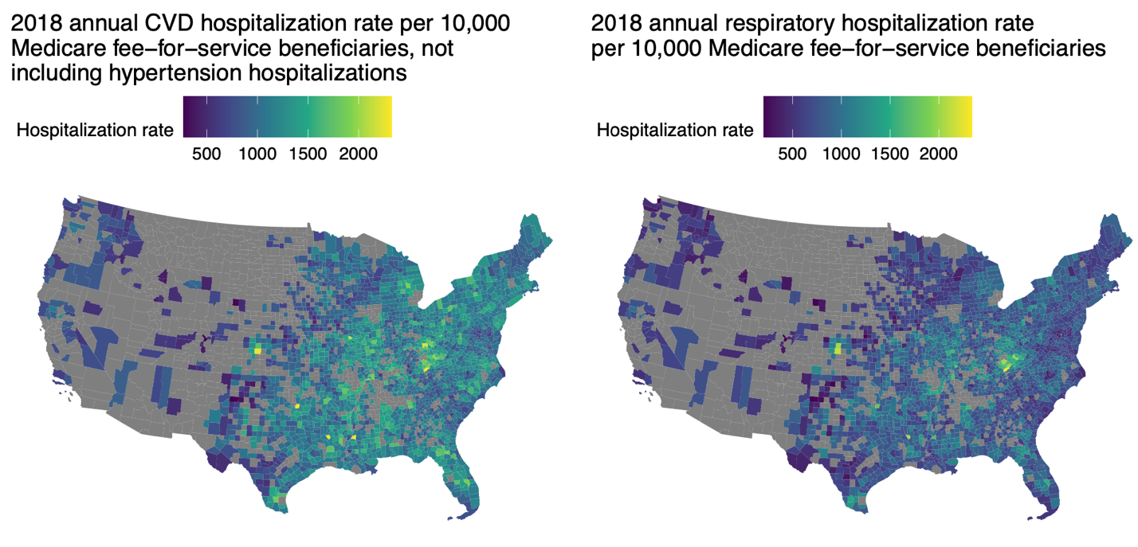

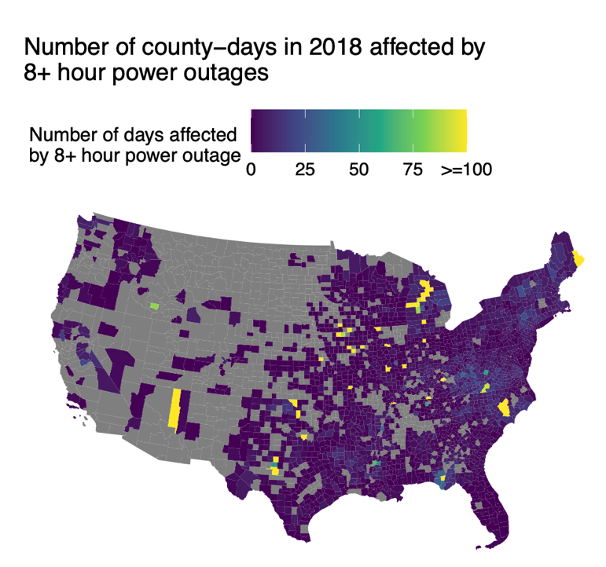

**Figure 1:** 2018 Medicare Fee-For-Service county-level cardiovascular hospitalization rate, respiratory hospitalization rate, and power outage rate for XX counties included in main analysis of association between 8+ hour power outage exposure and cardiovascular and respiratory hospitalization.

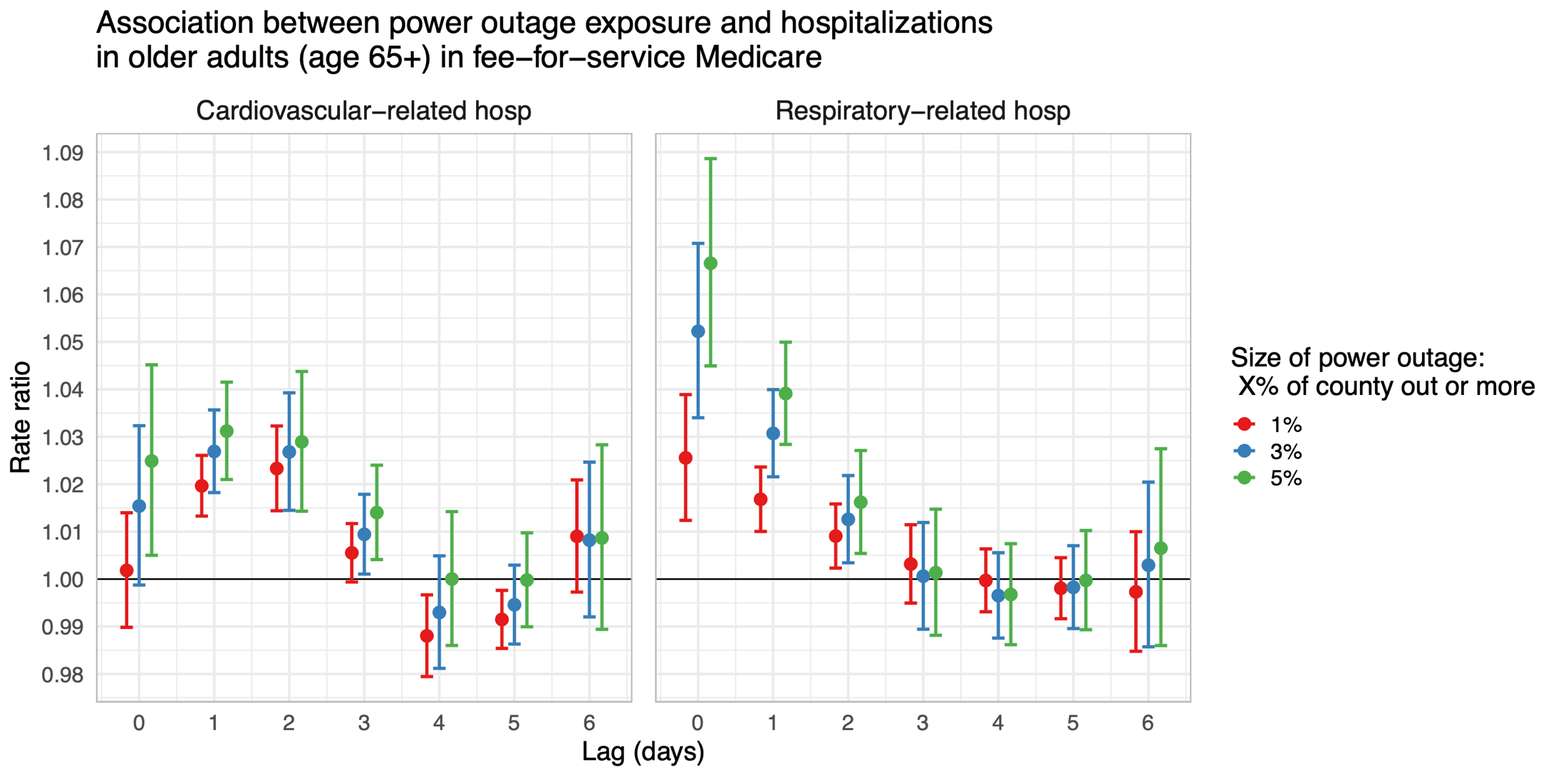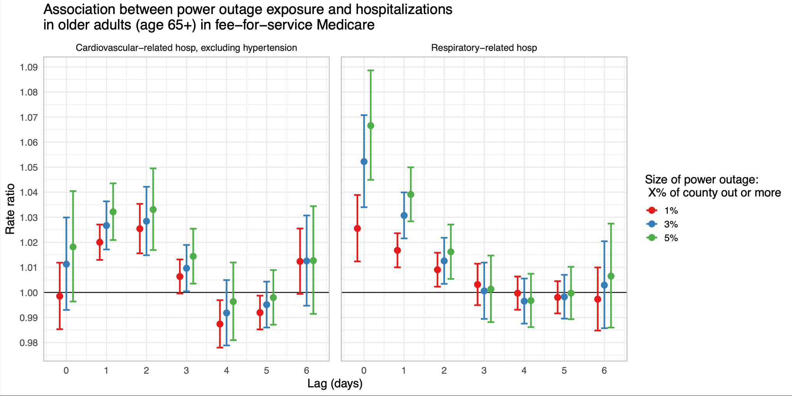

**Figure 2:** Rate ratios and 95% confidence intervals for the association between county-level 8+ hour power outage exposure and CVD and respiratory hospitalizations in US 2018 Fee-For-Service Medicare beneficiaries for outages affecting ≥1%, ≥3%, and ≥5% of county electrical customers. Estimates are from conditional logistic regression models adjusted for XYZ.

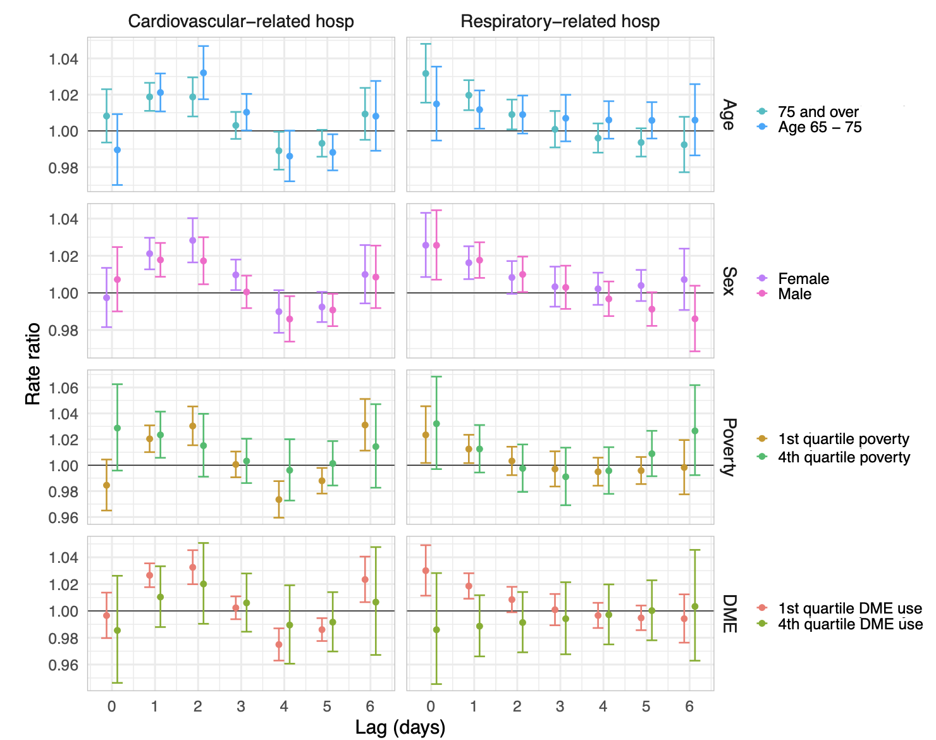

**Figure 3:** Estimates and confidence intervals for the association between 8+ hour power outage exposure and CVD and respiratory hospitalizations in US 2018 Fee-For-Service Medicare beneficiaries by potential effect modifiers: age, sex, county poverty quartile, and county DME use quartile.

**References**

1. Do V, McBrien H, Flores NM, Northrop AJ, Schlegelmilch J, Kiang MV, et al. Spatiotemporal distribution of power outages with climate events and social vulnerability in the USA. Nat Commun. 2023 Apr 29;14(1):2470.

2. Climate Central. Weather-related Power Outages Rising [Internet]. Climate Central; 2024 [cited 2024 Dec 5]. Available from: https://www.climatecentral.org/climate-matters/weather-related-power-outages-rising

3. Zhang W, Sheridan SC, Birkhead GS, Croft DP, Brotzge JA, Justino JG, et al. Power Outage: An Ignored Risk Factor for COPD Exacerbations. Chest. 2020 Dec;158(6):2346–57.

4. Lin S, Qi Q, Liu H, Deng X, Trees I, Yuan X, et al. The Joint Effects of Thunderstorms and Power Outages on Respiratory-Related Emergency Visits and Modifying and Mediating Factors of This Relationship. Environ Health Perspect. 2024 Jun;132(6):067002.

5. Dominianni C, Lane K, Johnson S, Ito K, Matte T. Health Impacts of Citywide and Localized Power Outages in New York City. Environ Health Perspect. 2018 Jun 15;126(6):067003.

6. Anderson GB, Bell ML. Lights Out: Impact of the August 2003 Power Outage on Mortality in New York, NY. Epidemiology. 2012 Mar;23(2):189–93.

7. Casey JA, Fukurai M, Hernández D, Balsari S, Kiang MV. Power Outages and Community Health: a Narrative Review. Curr Envir Health Rpt. 2020 Dec;7(4):371–83.

8. McBrien H, Mork D, Kioumourtzoglou MA, Casey JA. Assessing potential sources of bias in measuring power outage exposure with simulations. Under review at Environmental Health.

9. Armstrong BG, Gasparrini A, Tobias A. Conditional Poisson models: a flexible alternative to conditional logistic case cross-over analysis. BMC Med Res Methodol. 2014 Dec;14(1):122.

10. U.S. Energy Information Administration. U.S. electricity customers experienced eight hours of power interruptions in 2020 [Internet]. 2021 [cited 2024 Dec 5]. Available from: https://www.eia.gov/todayinenergy/detail.php?id=50316#

11. The US has more power outages than any other developed country. Here’s why. [Internet]. Popular Science; 2020 [cited 2024 Dec 5]. Available from: https://www.popsci.com/story/environment/why-us-lose-power-storms/

12. United States Environmental Protection Agency. Climate Change Impacts on Energy [Internet]. Available from: https://www.epa.gov/climateimpacts/climate-change-impacts-energy

13. Washington Post. Nation at risk of winter blackouts as power grid remains under strain [Internet]. Available from: https://www.washingtonpost.com/business/2023/11/08/power-grid-blackouts-texas/

14. Mango M, Casey JA, Hernández D. Resilient Power: A home-based electricity generation and storage solution for the medically vulnerable during climate-induced power outages. Futures. 2021 Apr;128:102707.

15. Stone B, Mallen E, Rajput M, Gronlund CJ, Broadbent AM, Krayenhoff ES, et al. Compound Climate and Infrastructure Events: How Electrical Grid Failure Alters Heat Wave Risk. Environ Sci Technol. 2021 May 18;55(10):6957–64.

16. Nunes AR. General and specified vulnerability to extreme temperatures among older adults. International Journal of Environmental Health Research. 2020 Sep 2;30(5):515–32.

17. Veronese N, Custodero C, Cella A, Demurtas J, Zora S, Maggi S, et al. Prevalence of multidimensional frailty and pre-frailty in older people in different settings: A systematic review and meta-analysis. Ageing Research Reviews. 2021 Dec;72:101498.

18. Weiss CO, Boyd CM, Yu Q, Wolff JL, Leff B. Patterns of Prevalent Major Chronic Disease Among Older Adults in the United States. JAMA. 2007 Sep 12;298(10):1158.

19. Yazdanyar A, Newman AB. The Burden of Cardiovascular Disease in the Elderly: Morbidity, Mortality, and Costs. Clinics in Geriatric Medicine. 2009 Nov;25(4):563–77.

20. Dahlberg L, McKee KJ, Frank A, Naseer M. A systematic review of longitudinal risk factors for loneliness in older adults. Aging & Mental Health. 2022 Feb 1;26(2):225–49.

21. Hoang P, King JA, Moore S, Moore K, Reich K, Sidhu H, et al. Interventions Associated With Reduced Loneliness and Social Isolation in Older Adults: A Systematic Review and Meta-analysis. JAMA Netw Open. 2022 Oct 17;5(10):e2236676.

22. Oak Ridge National Laboratory. Oak Ridge National Laboratory, EAGLE-I Outage Data 2014-2022 [Internet]. [cited 2025 Jan 3]. Available from: https://smc-datachallenge.ornl.gov/eagle/

23. Xiao J, Zhang W, Huang M, Lu Y, Lawrence WR, Lin Z, et al. Increased risk of multiple pregnancy complications following large-scale power outages during Hurricane Sandy in New York State. Science of The Total Environment. 2021 May;770:145359.

24. Skarha J, Gordon L, Sakib N, June J, Jester DJ, Peterson LJ, et al. Association of Power Outage With Mortality and Hospitalizations Among Florida Nursing Home Residents After Hurricane Irma. JAMA Health Forum. 2021 Nov 24;2(11):e213900.

25. Do V, Wilner LB, Flores NM, McBrien H, Northrop AJ, Casey JA. Spatiotemporal patterns of power outages co-occurring with individual and multiple severe weather events in the United States, 2018-2020 [Internet]. 2024 [cited 2025 Jan 4]. Available from: https://www.researchsquare.com/article/rs-4752336/v1

26. PowerOutage.us [Internet]. Available from: https://poweroutage.us/

27. U.S. Energy Information Administration Electricity Data [Internet]. [cited 2024 Jan 3]. U.S. Energy Information Administration Electricity Data. Available from: https://www.eia.gov/electricity/data.php

28. Do V. The impact of power outages on cardiovascular hospitalizations among Medicare enrollees in New York State, 2017-2018. Under review at Epidemiology.

29. Northrop AJ, Flores NM, Do V, Sheffield PE, Casey JA. Power outages and pediatric unintentional injury hospitalizations in New York State. Environmental Epidemiology. 2024 Feb;8(1):e287.

30. Gronlund CJ, Sullivan KP, Kefelegn Y, Cameron L, O’Neill MS. Climate change and temperature extremes: A review of heat- and cold-related morbidity and mortality concerns of municipalities. Maturitas. 2018 Aug;114:54–9.

31. Tseng CM, Chen YT, Ou SM, Hsiao YH, Li SY, Wang SJ, et al. The Effect of Cold Temperature on Increased Exacerbation of Chronic Obstructive Pulmonary Disease: A Nationwide Study. Chaturvedi S, editor. PLoS ONE. 2013 Mar 15;8(3):e57066.

32. Alahmad B, Khraishah H, Royé D, Vicedo-Cabrera AM, Guo Y, Papatheodorou SI, et al. Associations Between Extreme Temperatures and Cardiovascular Cause-Specific Mortality: Results From 27 Countries. Circulation. 2023 Jan 3;147(1):35–46.

33. Abatzoglou JT. Development of gridded surface meteorological data for ecological applications and modelling. Intl Journal of Climatology. 2013 Jan;33(1):121–31.

34. Salman HM, Pasupuleti J, Sabry AH. Review on Causes of Power Outages and Their Occurrence: Mitigation Strategies. Sustainability. 2023 Oct 18;15(20):15001.

35. Deng X, Friedman S, Ryan I, Zhang W, Dong G, Rodriguez H, et al. The independent and synergistic impacts of power outages and floods on hospital admissions for multiple diseases. Science of The Total Environment. 2022 Jul;828:154305.

36. Klinger C, Landeg O, Murray V. Power Outages, Extreme Events and Health: a Systematic Review of the Literature from 2011-2012. PLOS Currents [Internet]. 2014 Jan 2; Available from: https://pmc.ncbi.nlm.nih.gov/articles/PMC3879211/